UI Design
Wandora AI Travel Planning Prototype
All screenshots show only the UI output. Descriptions are written below each screen in this document.

Included outputs: 1 design theme screen, 2 landing page options, and 12 app prototype screens covering dashboard, create-trip flow, selected-trip overview, and itinerary editing.

Design Theme - Visual System
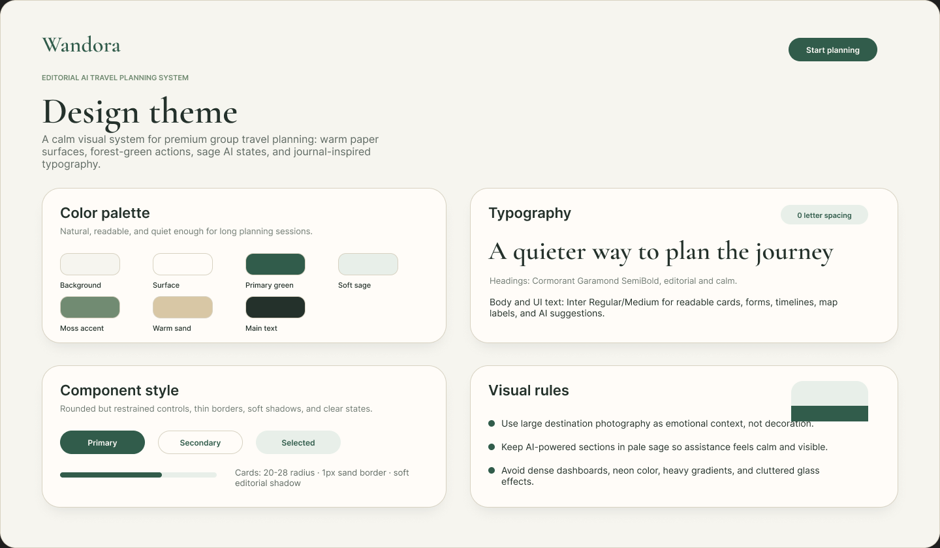
Purpose: Defines Wandora's visual direction so every screen feels consistent, calm, premium, and travel-focused.
What it shows: Core color palette, typography pair, control styles, card treatment, spacing mood, and visual usage rules.
How users use it: Designers and developers use this as a reference for checking colors, fonts, buttons, cards, and visual consistency.

Landing Page A - Editorial Travel Journal
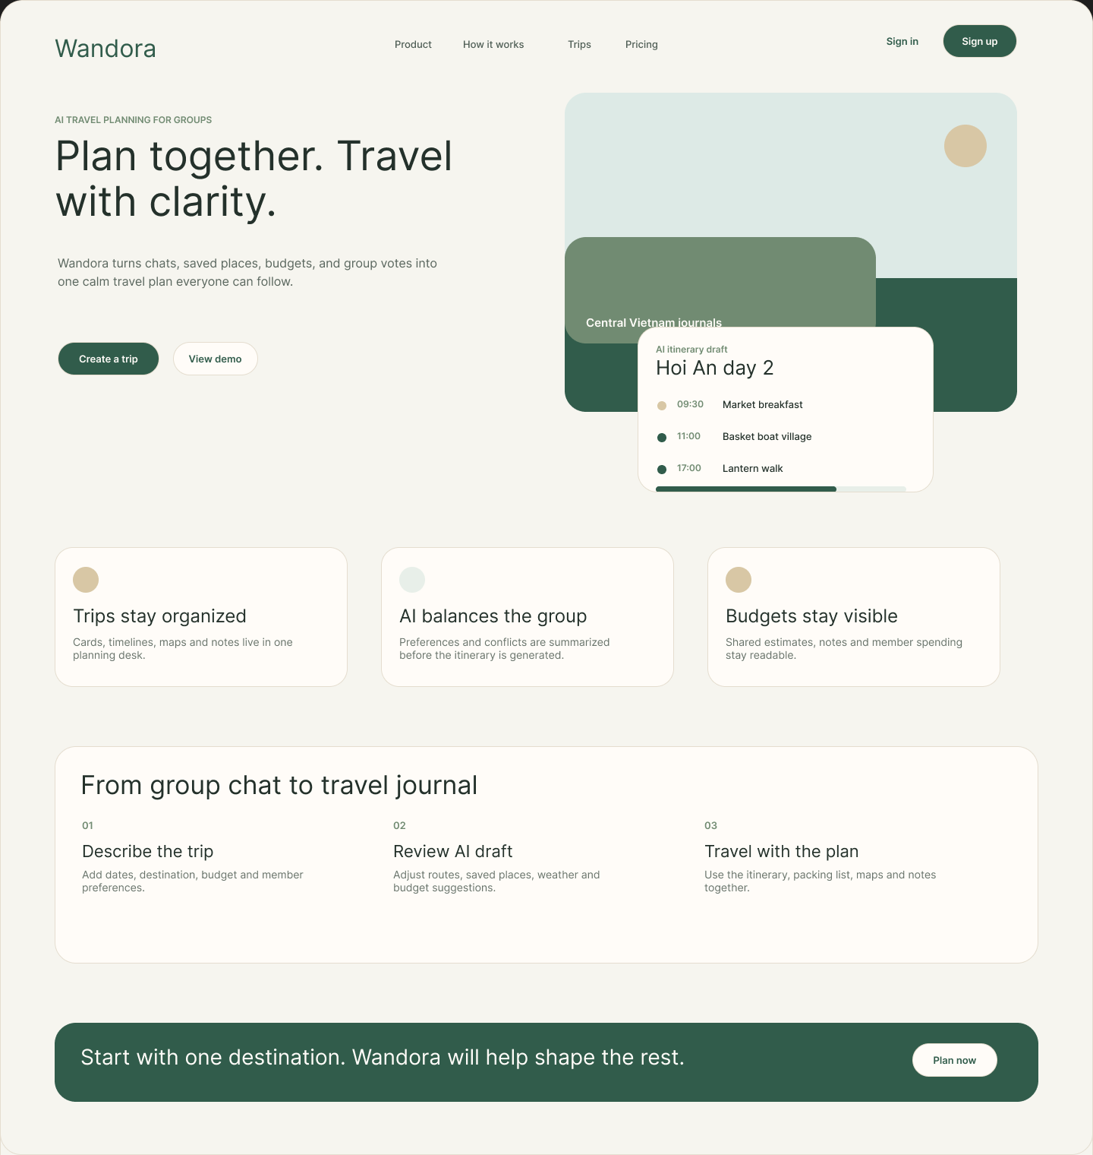
Purpose: Introduces Wandora as a peaceful AI travel journal for collaborative group planning.
What it shows: Navigation, hero offer, destination photography, itinerary preview, feature cards, workflow, and final CTA.
How users use it: Users learn the product value, scan core features, understand the planning flow, and start planning or view a demo.

Landing Page B - Product Assistant
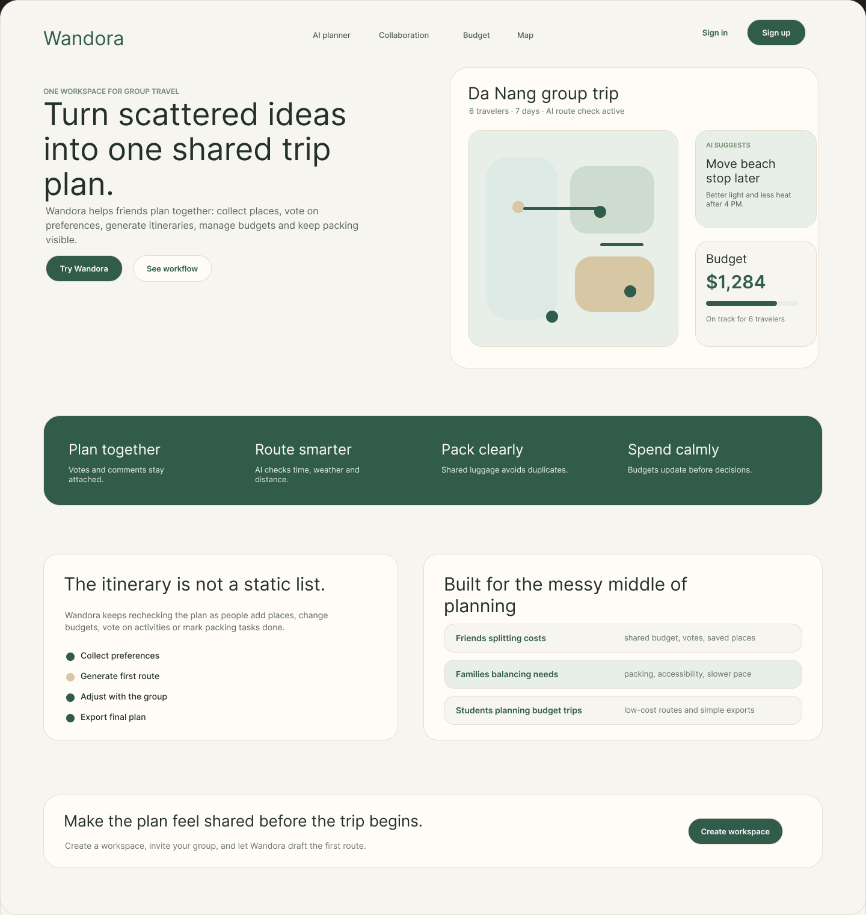
Purpose: Explains Wandora as an AI assistant workspace for planning group trips together.
What it shows: Hero copy, app preview, route map, AI suggestion, budget card, benefit strip, workflow, and sign-up CTA.
How users use it: Users understand the product interface quickly, compare benefits, see target use cases, and start a workspace.

Screen 1A - Dashboard / My Trips Grid
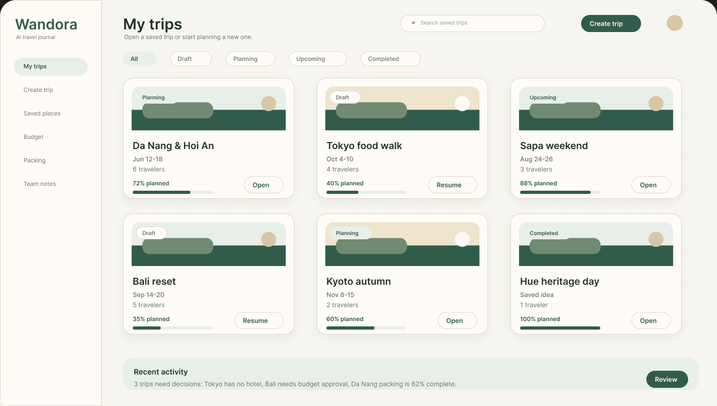
Purpose: Saved-trips dashboard for finding an existing trip or starting a new one.
What it shows: Saved trip grid, create-trip button, search, filters, status chips, dates, travelers, progress, and open/resume actions.
How users use it: Users filter saved trips, scan progress and status, resume a draft, open a trip, or create a new trip.

Screen 1B - Dashboard / Featured Trip Board
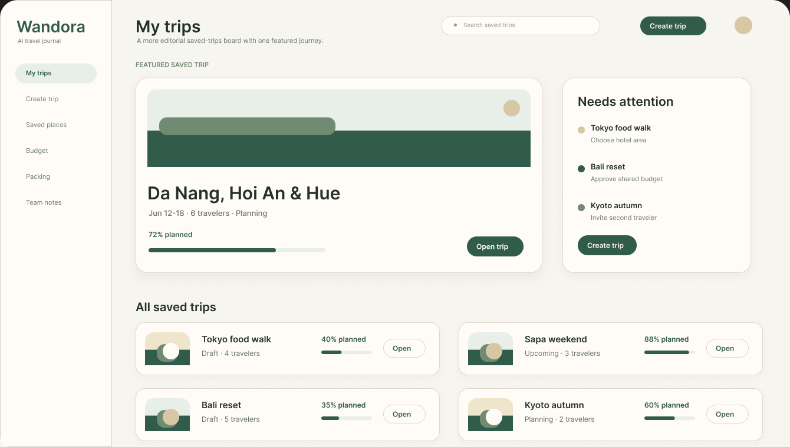
Purpose: Alternative dashboard that highlights the most important saved trip while keeping the trip list readable.
What it shows: Featured saved trip, attention tasks, create-trip button, search, and compact saved-trip rows.
How users use it: Users open the featured journey, review pending planning tasks, browse saved trips, or create a new trip.

Screen 2A - Create Trip Step 1 / Invite Members
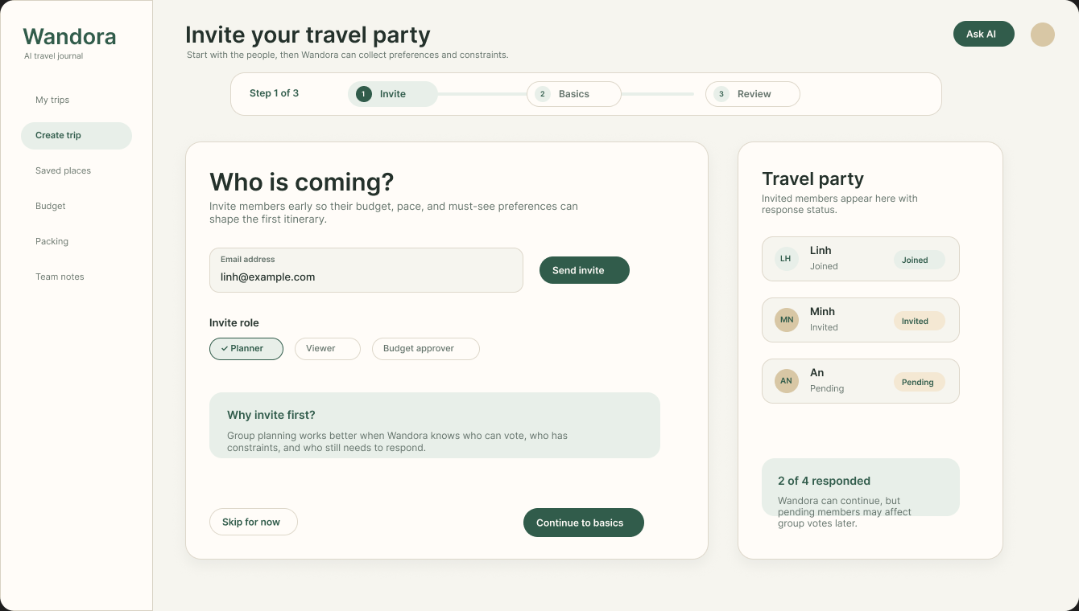
Purpose: Invite-first setup screen so group preferences can shape the first itinerary.
What it shows: Email invite field, invite role controls, travel party list, member statuses, and response count.
How users use it: Users invite members, choose roles, review who has joined, and continue to basic trip details.

Screen 2B - Create Trip Step 1 / Invite Link
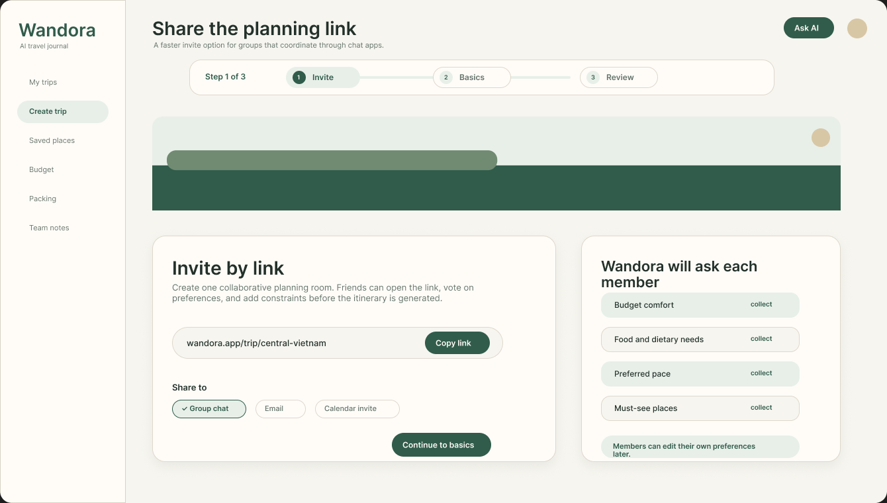
Purpose: Alternative invite-first screen for groups that prefer sharing one planning link.
What it shows: Shareable invite link, invite settings, role permissions, member status list, and progress to the next step.
How users use it: Users copy the invite link, set who can edit or vote, check invite status, and continue to basics.

Screen 3A - Create Trip Step 2 / Guided Basics
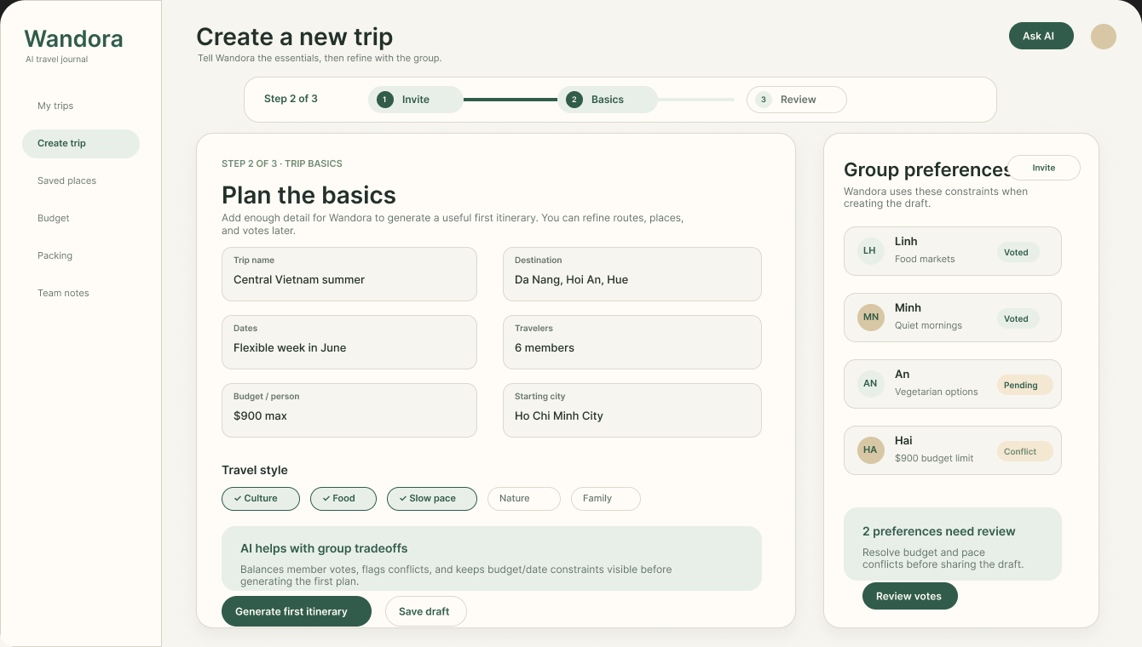
Purpose: Guided basics form for users who want clear fields and low cognitive load.
What it shows: Trip name, destination, dates, travelers, budget, starting city, travel style, AI help, and group summary.
How users use it: Users complete trip basics, save a draft, or continue after reviewing group constraints.

Screen 3B - Create Trip Step 2 / Conversational Basics
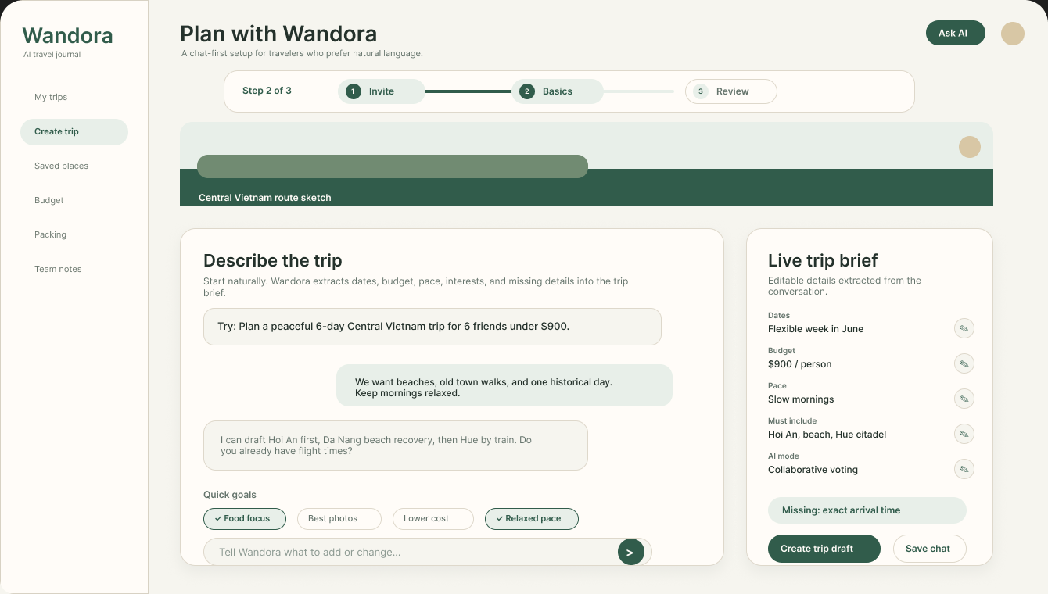
Purpose: Chat-first setup for users who prefer describing a trip naturally.
What it shows: Route preview, starter prompt, chat messages, quick goals, live trip brief, missing details, and draft actions.
How users use it: Users describe the trip, answer follow-ups, and continue when the brief has enough information.

Screen 4A - Create Trip Step 3 / Preferences & Review
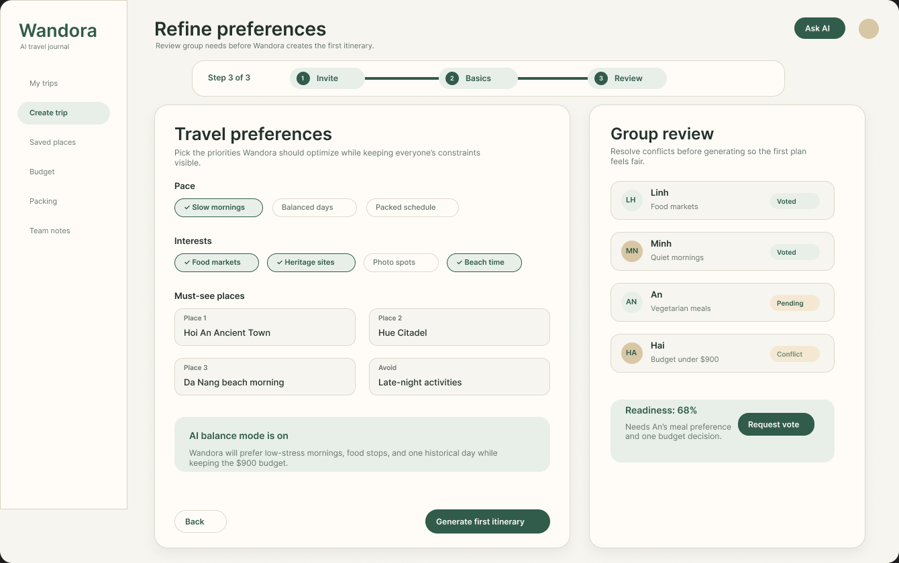
Purpose: Guided preference review before generating the first itinerary.
What it shows: Pace choices, interests, must-see places, avoid list, AI balance explanation, group votes, and readiness status.
How users use it: Users choose preferences, resolve pending votes or conflicts, and generate the first itinerary when ready.

Screen 4B - Create Trip Step 3 / AI Review Board
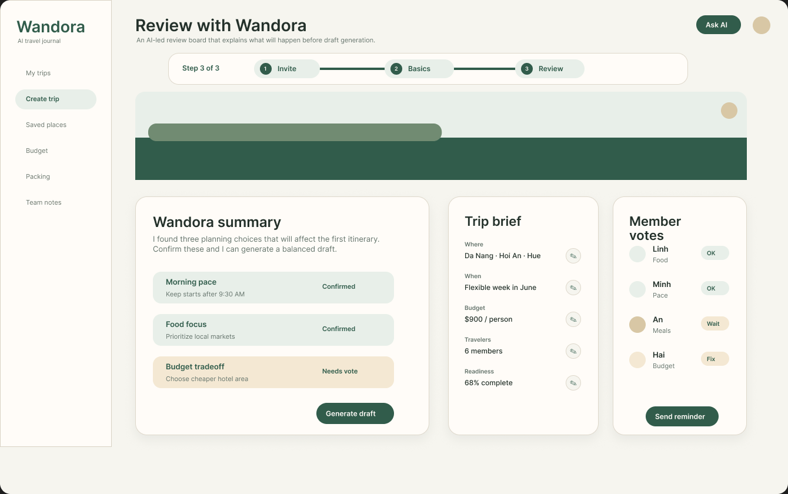
Purpose: AI-led review screen that explains planning decisions before draft creation.
What it shows: Route preview, AI decision summary, editable trip brief, member vote states, reminders, and generate-draft action.
How users use it: Users review Wandora's interpretation, edit the brief, send reminders, and generate a draft once decisions are clear.

Screen 5A - Selected Trip Overview / Summary
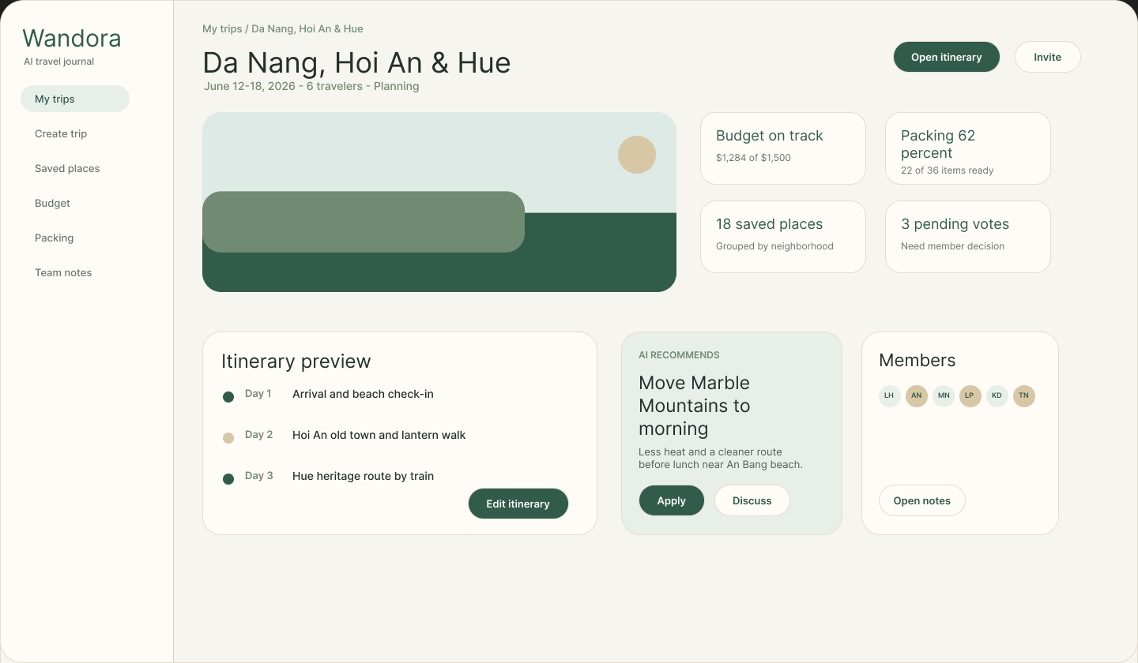
Purpose: Selected-trip overview for understanding one saved trip at a glance.
What it shows: Trip hero, dates, travelers, status, itinerary preview, AI recommendation, budget, packing, saved places, votes, and notes.
How users use it: Users open the itinerary workspace, invite members, accept AI suggestions, or review notes.

Screen 5B - Selected Trip Overview / Planning Board
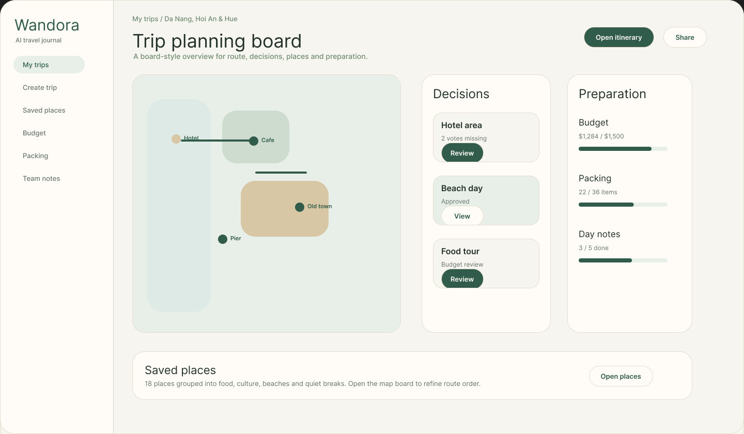
Purpose: Alternative selected-trip overview organized by map, decisions, and preparation status.
What it shows: Route map summary, decision cards, budget progress, packing progress, saved places, member notes, and itinerary actions.
How users use it: Users review trip readiness, resolve decisions, inspect saved places, share the trip, or open the itinerary workspace.

Screen 6A - Itinerary Workspace / Timeline
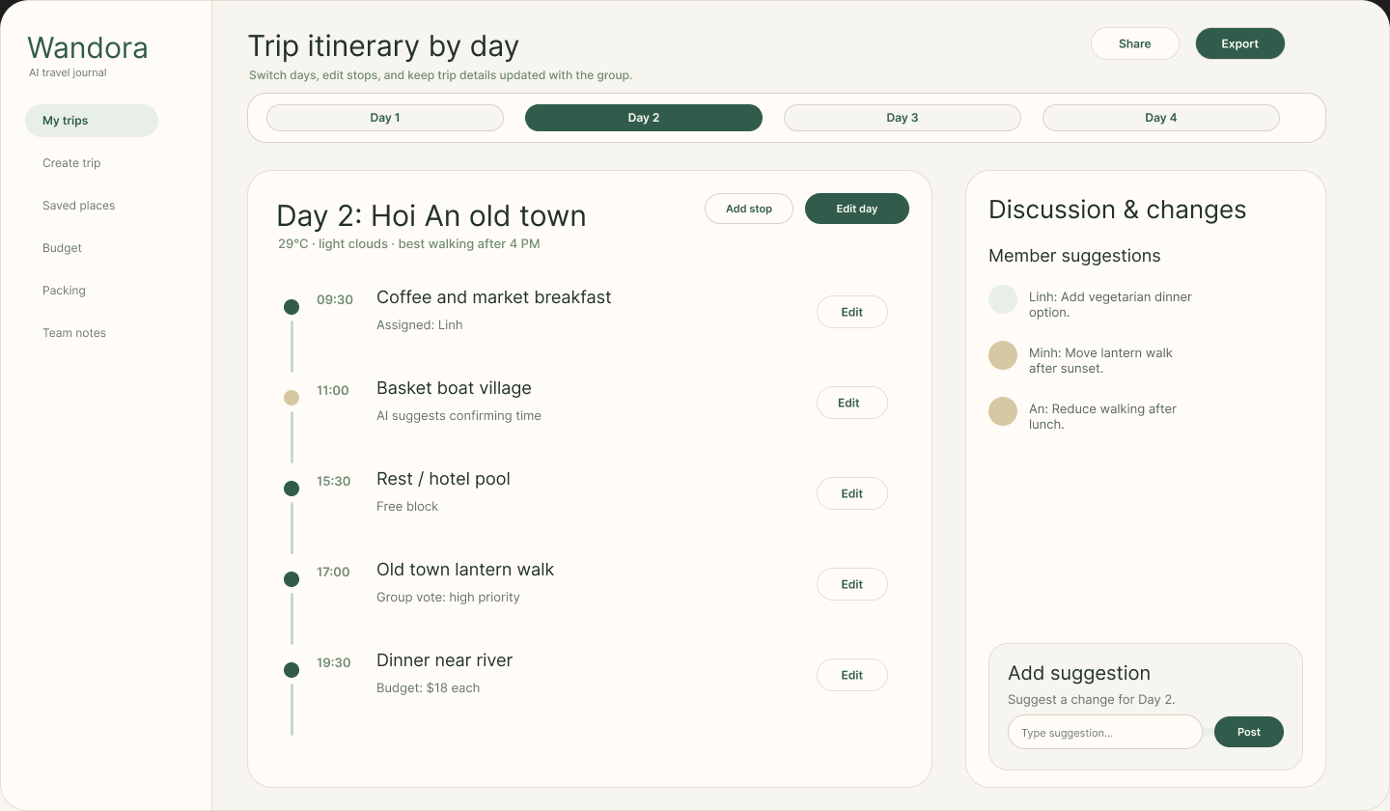
Purpose: Day-by-day itinerary screen for viewing, editing, and adding stops to the selected travel day.
What it shows: Day tabs, selected-day timeline, editable stop actions, decision card, member suggestions, and AI support.
How users use it: Users switch days, edit activities, add stops, review team suggestions, and post new changes.

Screen 6B - Itinerary Workspace / Map Board
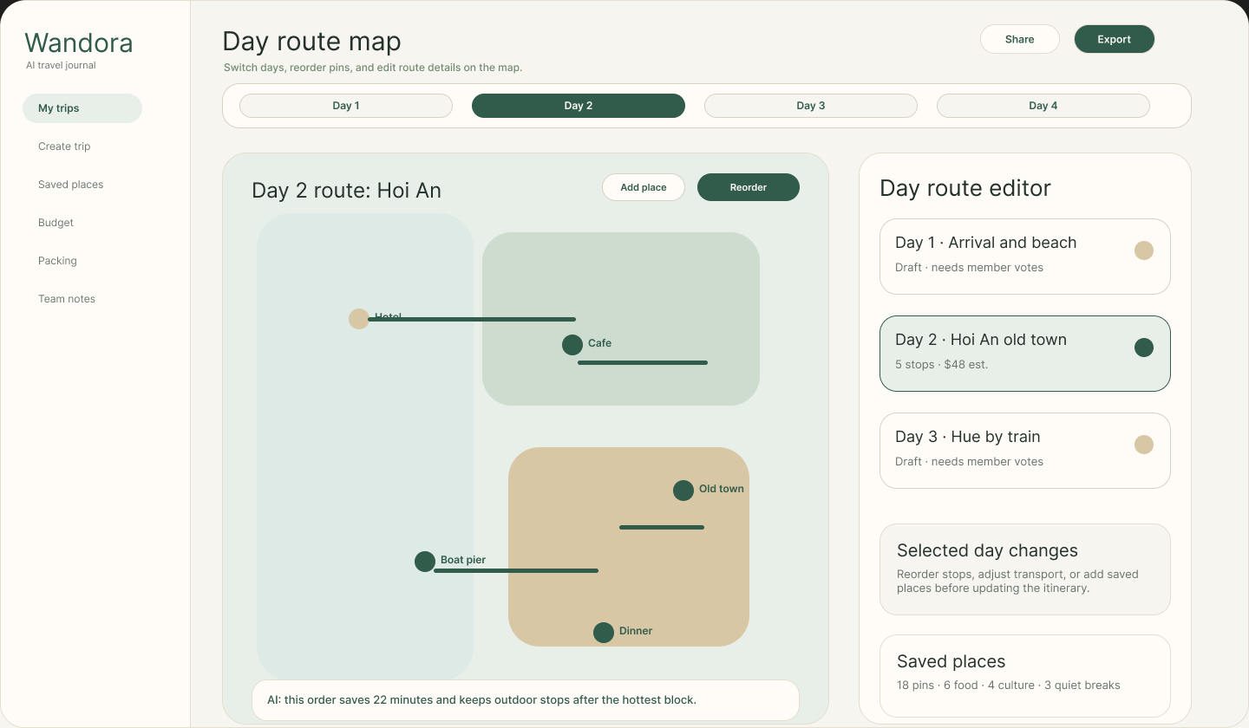
Purpose: Map-based itinerary screen for editing route order and places for the selected day.
What it shows: Day tabs, active route map, pins, route controls, day cards, selected-day changes, budget, and saved places.
How users use it: Users switch days, add places, reorder route pins, compare day cards, and update the itinerary route.

